**1.Develop a program to display grayscale image using read and write operation.**

**------------------------------------------------------------------------------------**

**import cv2**

**import numpy as np**

**image = cv2.imread('wolf1.jpg')**

**image = cv2.resize(image, (0, 0), None, .25, .25)**

**gray = cv2.cvtColor(image, cv2.COLOR_RGB2GRAY)**

**gray_3_channel = cv2.cvtColor(grey, cv2.COLOR_GRAY2BGR)**

**numpy_horizontal = np.hstack((image, gray_3_channel))**

**numpy_horizontal_concat = np.concatenate((image, gray_3_channel), axis=1)**

**cv2.imshow('wolf', numpy_horizontal_concat)**

**cv2.waitKey()**

**OUTPUT**

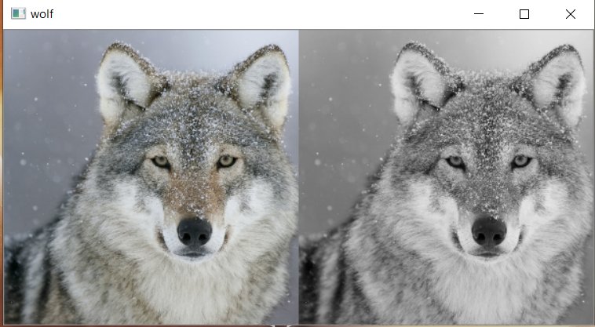

**2.Develop a program to perform linear transformation on image.**

**------------------------------------------------------------------------------------------------**

**import cv2**

**import numpy as np**

**FILE_NAME = 'wolf1.jpg'**

**try:**

**img = cv2.imread(FILE_NAME)**

**(height, width) = img.shape[:2]**

**res = cv2.resize(img, (int(width / 2), int(height / 2)), interpolation = cv2.INTER_CUBIC)**

**cv2.imwrite('result.jpg', res)**

**cv2.imshow('image',img)**

**cv2.imshow('result',res)**

**cv2.waitKey(0)**

**except IOError:**

**print ('Error while reading files !!!')**

**cv2.waitKey(0)**

**cv2.destroyAllWindows(0)**

**Output:**

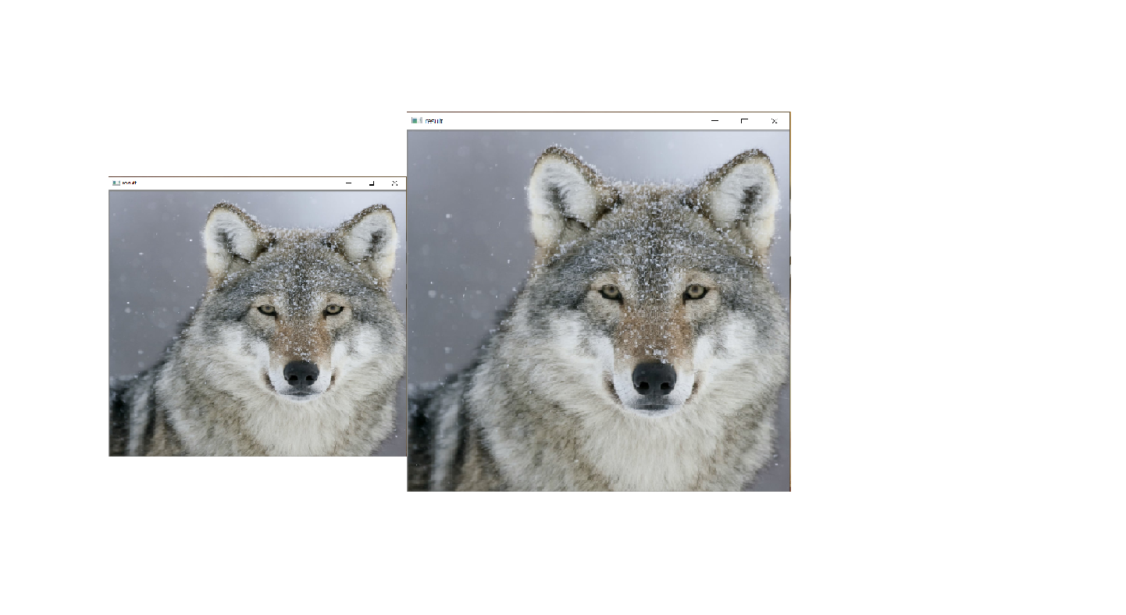

**import cv2**

**import numpy as np**

**FILE_NAME = 'wolf1.jpg'**

**img = cv2.imread(FILE_NAME)**

**(rows, cols) = img.shape[:2]**

**M = cv2.getRotationMatrix2D((cols / 2, rows / 2), 45, 1)**

**res = cv2.warpAffine(img, M, (cols, rows))**

**cv2.imshow('result.jpg', res)**

**cv2.waitKey(0)**

**Output:**

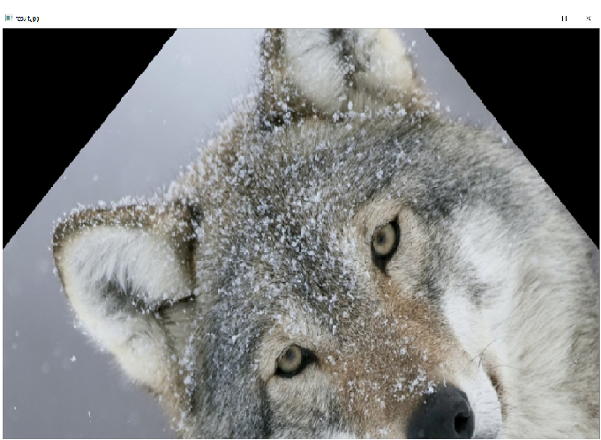

**3.Develop a program to find sum and mean of a set of images.**

**Create n number of images and read the directory and perform operation.**

**------------------------------------------------------------------------------------------------**

**import cv2**

**import os**

**path = "E:\IP\Resize"**

**imgs=[]**

**dirs=os.listdir(path)**

**for file in dirs:**

**fpat=path+"\\"+file**

**imgs.append(cv2.imread(fpat))**

**i=0**

**for im in imgs:**

**cv2.imshow(dirs[i],imgs[i])**

**i=i+1**

**print(i)**

**cv2.imshow('sum',len(im))**

**cv2.imshow('mean',len(im)/im)**

**cv2.waitKey(0)**

**Output:**

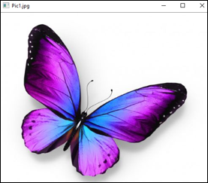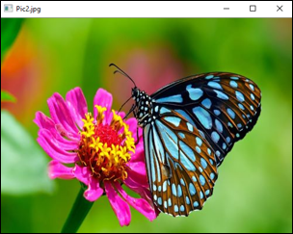

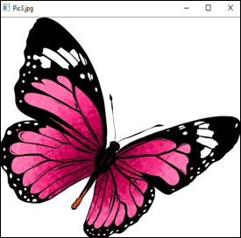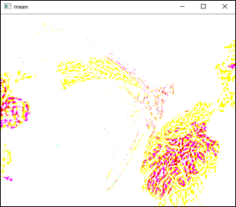

**4.Write a program to convert color image into gray scale and binary image.**

**------------------------------------------------------------------------------------------------**

**import cv2**

**img = cv2.imread("wolf2.jpg")**

**gray=cv2.cvtColor(img,cv2.COLOR_BGR2GRAY)**

**cv2.imshow("Binary Image",gray)**

**cv2.waitKey(0)**

**cv2.destroyAllWindows()**

**ret, bw_img = cv2.threshold(img,127,255,cv2.THRESH_BINARY)**

**cv2.imshow("Binary Image",bw_img)**

**cv2.waitKey(0)**

**cv2.destroyAllWindows()**

**Output:**

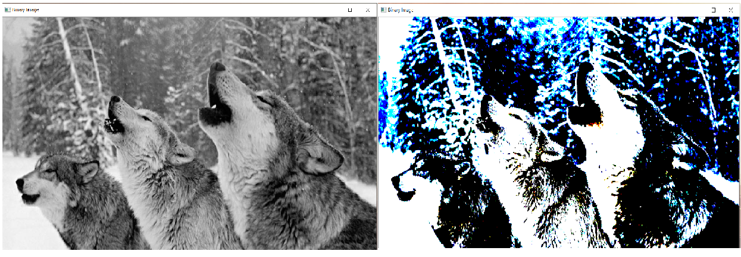

**5.Write a program to convert color image into different color space.**

**------------------------------------------------------------------------------------------------**

**import cv2**

**img = cv2.imread("dog.jpg")**

**gray=cv2.cvtColor(img,cv2.COLOR_BGR2GRAY)**

**hsv=cv2.cvtColor(img,cv2.COLOR_BGR2HSV)**

**lab=cv2.cvtColor(img,cv2.COLOR_BGR2LAB)**

**hls=cv2.cvtColor(img,cv2.COLOR_BGR2HLS)**

**cv2.imshow("GRAY image",gray)**

**cv2.waitKey(0)**

**cv2.imshow("HSV image",hsv)**

**cv2.waitKey(0)**

**cv2.imshow("LAB image",lab)**

**cv2.waitKey(0)**

**cv2.imshow("HLS image",hls)**

**cv2.waitKey(0)**

**cv2.destroyAllWindows()**

**ret, bw_img = cv2.threshold(img,127,255,cv2.THRESH_BINARY)**

**cv2.destroyAllWindows()**

**Output:**

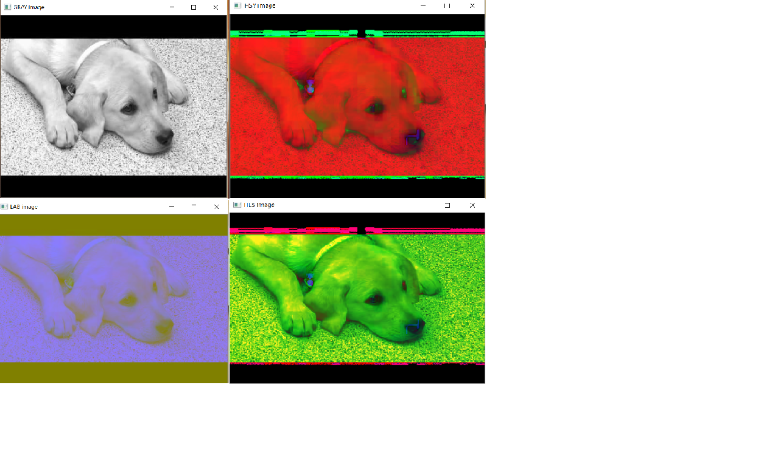

**6.Develop a program to create an image from 2D array.**

**import numpy as np**

**from PIL import Image**

**import cv2 as c**

**array = np.zeros([100, 200, 3], dtype=np.uint8)**

**array[:,:100] = [150, 128, 0] #Orange left side**

**array[:,100:] = [0, 0, 255] #Blue right side**

**img = Image.fromarray(array)**

**img.save('Panda.jpg')**

**img.show()**

**c.waitKey(0)**

**Output:**

